Requirement
- OCR Scanner for document like pdf, doc, jpeg and other available types.
- Scanned document has be saved and can be review
- AI driven document categorization
- Integration of ocr, accounting system, audit system, tax system
...To be continues

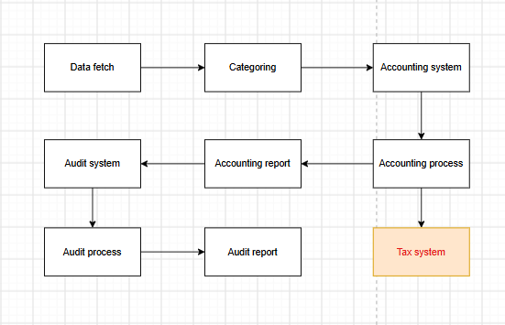
The flowchart outlines the complete automated data processing and business workflow based on requirements, covering everything from raw data retrieval to financial, tax, and audit processing.

1. Data Collection & Bookkeeping Flow
  - Data fetch: Retrieves raw business data from external systems, APIs, or databases.

  - Categorizing: Cleans and organizes the retrieved data.

  - Accounting system: Imports the structured data into the accounting system.

  - Accounting process: Performs bookkeeping, accounting calculations, and adjustments within the system.

2. Dual Business Branches
Tax Branch:

  - Tax system: Extends from the accounting process to the tax system for subsequent tax calculation and compliance reporting.

Audit & Reporting Branch:

  - Accounting report: Generates financial statements following the accounting process.

  - Audit system: Inputs the financial reports into the audit system.

  - Audit process: Conducts audit verification and procedural execution.

  - Audit report: Ultimately generates and outputs the audit report.
Accounting system
- Tax manual setup
- Stock manual setup
- Report generation

Audit system
....To be continues
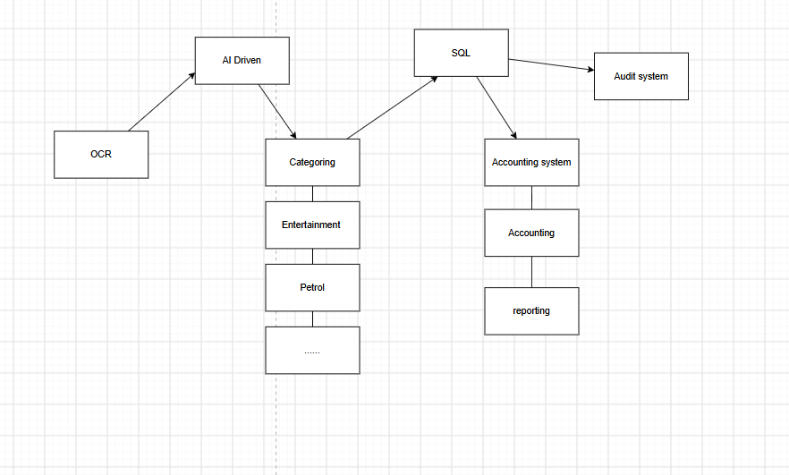
The general data flow for integrated system is shown on above, from OCR input the data until final report with automatic for scope to decrease the human error and increase the data accurate.

Phase 1
Architecture for data Fetching and Storage

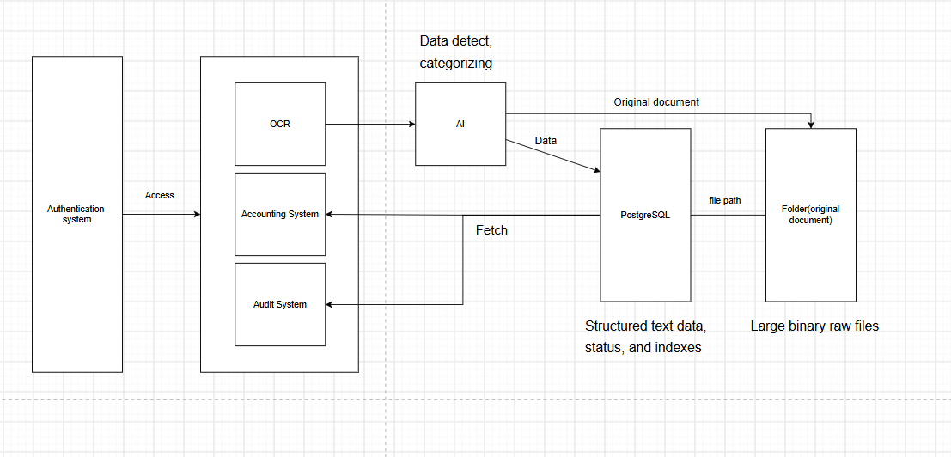
OCR

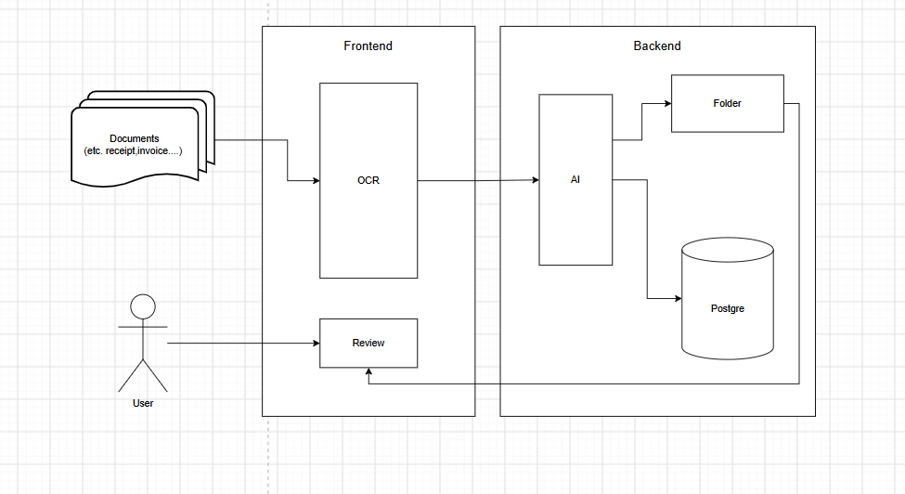
OCR scan the document like receipt, invoice and other. The AI detect the document and catch the data and do categorizing with the type like entertainment, petrol. The data will categorizing and save to related table in PostgreSQL. The original document will be saved to the folder and the related path also will be save in PostgreSQL.So that allow the user review the document when need, the viewer can easily follow the path save in database to reopen the document.

Scope：
- AI can properly detect the document and get the data
- AI can properly categorizing data and document
- User can review the document are be scanned and saved

Remark:
That also need the approval system to processing or value the case like document processing by AI don't know how to categorizing or get error data.

Accounting system
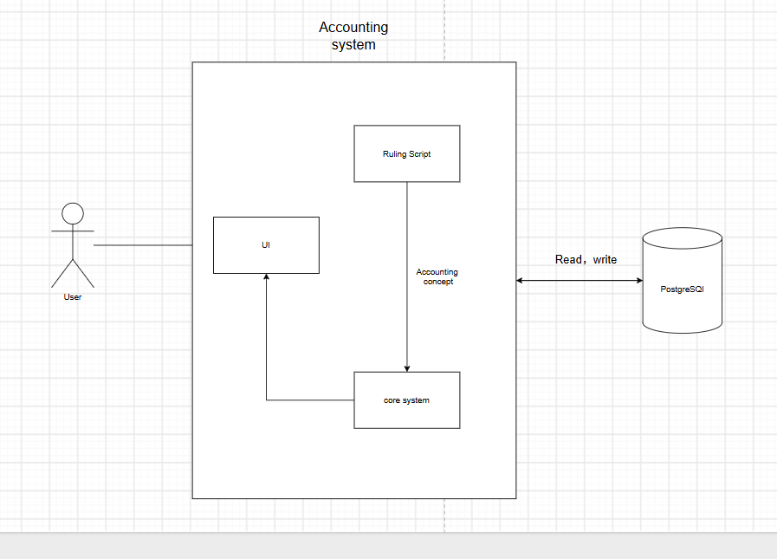
The above is the architecture of an accounting system

1. User
- The User is the person using the accounting application.
- They interact only with the UI (User Interface).
- They do not access the database or business logic directly.
Flow:
User → UI

2. UI (User Interface)
The UI is the front-end of the system.
Its responsibilities are:
- Display forms, reports, and dashboards.
- Accept user input (e.g., create invoice, record payment).
- Send requests to the Core System.
- Display the results returned by the Core System.
Example:
- User enters a sales invoice.
- UI sends the invoice data to the Core System.
- UI displays whether it was successfully saved.

3. Core System
The Core System is the application's business logic.
It is responsible for:
- Processing accounting transactions.
- Validating data.
- Calling the ruling/accounting engine.
- Reading and writing data to PostgreSQL.
- Returning results to the UI.
Example:
User creates invoice
↓
UI
↓
Core System
↓
Store invoice
Calculate totals
Generate journal entries

4. Ruling Script (Accounting Rules)
This component contains the accounting logic or rules.
Examples of rules:
- Which account should be debited?
- Which account should be credited?
- How should VAT/GST be calculated?
- How should depreciation be posted?
- How should foreign currency be handled?
Instead of hardcoding these rules in the Core System, they are separated into a Ruling Script.

5. PostgreSQL Database
The PostgreSQL database stores all persistent data.
Examples:
- Customers
- Vendors
- Chart of Accounts
- Journal Entries
- Invoices
- Payments
- Financial Reports
- Users
The diagram indicates Read, write, meaning:
- Read existing records
- Insert new records
- Update records
- Delete records (if allowed)

Scope:
- Accounting system work properly with accounting ruling
- Accounting system all function run successful

Technical:
Frontend: reactJs + NextJs
Backend: postgreSQL
AI: Gemma 4

Audit system
To be continues....

